Nexelus Web Server

Server Setup

esm_logo.jpg

Nexelus USA  
New York, NEW YORK (NY)  
646-558-1950 ext.128

**1/25/2022**

# Document Information

The following table shows the details for document creation, review, approval, and effective date.

| **Category** | **Information** |
| --- | --- |
| Work Product: | Nexelus Web Server |
| Project Name: | Server Setup |
| Function Name: | Web Server Setup |
| Version: | 0.1 |
| Status: | Draft |
| Author(s): | Tauseef Shahzad |
| Reviewer(s): | Asim Jameel |
| Approver(s): | Imran Rahman |
| Control Status: | CONTROLLED, PROTECTED |
| Disclaimer: | This document contains confidential information. Do not distribute this document without prior approval from Nexelus. |

# Revision History

The following table is used for revision details of this document.

| **Author(s)** | **Date** | **Version** | **Description of Change** |
| --- | --- | --- | --- |
| Tauseef Shahzad | Jan 25, 2022 | 0.1 | Initial Draft |
| Mirza Asif Azim | Jan 25, 2022 | 0.1 | Additional information added |
| Anees Ur Rahman | Jan 25, 2022 | 0.1 | Crystal XI and eConnect information added |
|  |  |  |  |

# Table of Contents

Contents

[Document Information ii](#_Toc94011766)

[Revision History iii](#_Toc94011767)

[Table of Contents i](#_Toc94011768)

[Scope 1](#_Toc94011769)

[Windows Server Configurations 2](#_Toc94011770)

[Windows Roles and Features 3](#_Toc94011771)

[Additional Software 5](#_Toc94011772)

[Copy files and information from Source Server 6](#_Toc94011773)

[Setup files on new Server 7](#_Toc94011774)

# Scope

Scope of this document is to list steps required to configure Nexelus Web Server

# Windows Server Configurations

This section provides Windows Server configurations and roles and features required to setup Web Server on Windows Server.

## Windows Roles and Features

1. Turn off Enhanced Security

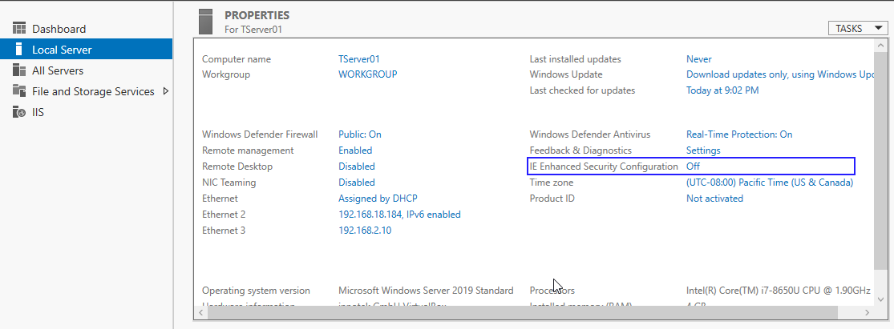

1. Setup Web Server and features
2. Install Web Server Role

1. Setup following features in Web server

## Additional Software

Following Installation is required before setup applications on new server, which includes dot Net Core setup, eConnect, and Crystal report files:

* **dotnet-hosting-2.2.7-win**
* **dotnet-sdk-2.2.109-win-x64**
* **Install Crystal Reports XI**

Install “CrystalReports11\_5\_NET\_2005” placed under webserver (172.28.28.4) C:\Pdm-Work\\_Install. It’s a simple automatically installation process, user only needs to provide required information during installation i.e. Product key information (placed under same \_install folder) and click next to complete installation.

* **Configure eConnect**

In current eConnect configuration we install eConnect only on SQL server. The webserver part is to register the dll’s only. Below are the steps.

The eConnect11Shell folder available on our webserver 172.28.28.5\c:\ eConnect11Shell.

e\_Connect11Shell folder contains.

1. eConnect\_12.5🡪 e\_connect.dll
2. e\_Connect10.dll
3. e\_Connect10.tlb
4. RegistereConnect10.bat
5. Un-RegistereConnect10.bat
6. Gac for assembly
7. connection.txt

Deploy the e\_connect.dll on web server with the regsvr32 command in run prompt.

Also run the batch file (RegistereConnect10.bat) available under eConnect11shell folder as administrator to register the e\_Connect10.dll and e\_Connect10.tlb.

After register the e\_Connect10.dll run the Gac for Assembly to copy the e\_Connect10.dll in C:\Windows\Assembly

Share a folder on web server which should be accessible from SQL server. Map the folder using Map drive. Once you shared the folder then try access from SQL server thru XP\_cmdshell, it should be accessible.

Update the connection.txt file with the correct SQL server name and credentials and the path which is shared on web server e.g., c:\econnect\

Apply necessary changes to the pdsw\_eCon\_shellposting sp on the database e.g. eConnGP2. The shared path should be same we have in the connection.txt file. To access the folder thru SQL below is an example command

exec xp\_cmdshell 'dir \\108.171.165.86\econnect\'

* Add All Svc Handler mapping to new server manually likewise webserver 01  
  Graphical user interface, text, application

  Description automatically generated

## Copy files and information from Source Server

1. Login to existing web server
2. Share C Drive of webserver 01 with new webserver so that data can be move -
3. Create backup of websites and folders from Webserver 01 and move it to new server

Note: Document folder and reports folders needs to unselect while moving data from one server to another server because Documents and reports resides on Fileserver.

1. Export Application Pools and Websites
2. Export Application Pools from IIS

From command prompt execute following command

*%windir%*\system32\inetsrv\appcmd list apppool /config /xml > c:\apppools.xml

1. Export Website configurations from IIS

From command prompt execute following command

*%windir%\system32\inetsrv\appcmd list site /config /xml > c:\websites.xml*

1. Create iisconfig.zip file for websites.xml and apppools.xml

## Setup files on new Server

Export Pool and Websites from existing server:

1. Copy backup folders on new server
2. Copy iisconfig.zip to new server and extract in a temp folder
3. Import Application Pools and Websites in new web server
4. Run following command on command prompt to import pools

*%windir%\system32\inetsrv\appcmd list apppool "CustomAppPool" /config /xml > customapppool.xml*

1. Run following command to import websites

*%windir%\system32\inetsrv\appcmd add apppool /in < c:\customapppool.xml*

1. Run following additional steps to finalize application deployments

* Update all application pool settings likewise webserver 01 application pools
* Create file server links on new server for Report server under each client report server deployment
* Create document folder link on new server
* Smoke testing